

DISCOVERY POINT

Treasure Hunt 2

Can you find these 10 things around the museum?
- Bottle of Discovery Whisky

- Wooden skis

- Captain Scott’s pipe
- Rifle
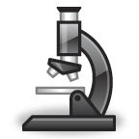
- Microscope
- Penguin

- Medals
- Sword
- Ship’s Bell
- Old-fashioned Camera
Trail Sheet on other side

