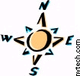
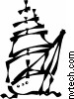
DISCOVERY POINT

Treasure Hunt 1

Can you find these 10 things around the museum?
- Giant tin of Colman’s mustard
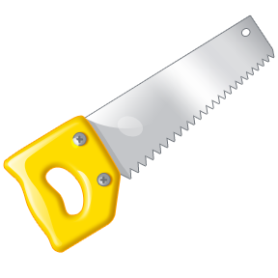
- Saw
- Dominoes

- Woollen socks
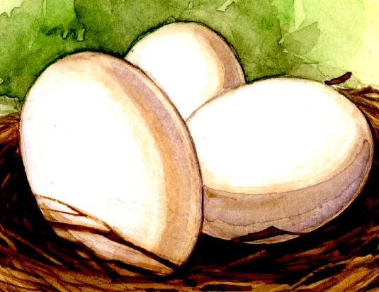
- Penguin eggs
- Binoculars

- Telescope

- Digestive biscuits (left from Captain
Scott’s second journey!)
- Teapot
- Whale’s jaw bone
Trail Sheet on other side

